THE WATER CYCLE

97% of the world’s water is in the oceans, 2% in glaciers and 1% is in surface streams / rivers and underground.

The Sun continuously evaporates water from the soil, streams, lakes, etc. Plants and animals transpire and respire. The vapour rises to higher parts in the atmosphere where it cools and forms clouds. As the droplets grow in size, they fall as rain. The water eventually finds its way back to the ocean via underground, streams and rivers. The cycle then continues.

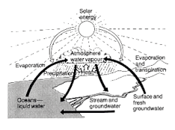
Time scale for the cycle

• Water in the atmosphere is replenished every 10 days.
• Streams / rivers is weeks.
• Soil is months.
• Ground water is hundreds of years.
• Ice caps is thousands of years.

The diagram below shows the water flow from the Gnangara Mound in the northern suburbs of Perth.

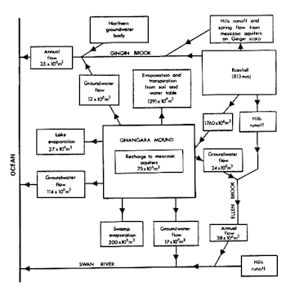

Most, if not all, of the water used in the northern suburbs comes from below the ground.

